Honeywell Sensing & Productivity Solutions
315 East Stephenson Street
Freeport Illinois 61032
Tel: (815) 235-6591

2015
Dear Customer
Honeywell Sensing & Productivity Solutions takes its compliance with REACH Regulation very seriously.
As part of our ongoing compliance commitment, we have completed a process to identify which, if any, substances of very high concern (SVHCs), (meeting the criteria set out in Article 57 of REACH and included on the REACH "Candidate List" for further regulation), are contained within the product we supply to you and in what concentrations.

This communication refers to the latest version of the ECHA Candidate List dated below.

Manufacturer Part Numbers: | NGC Platform Products
Date of Candidate List: | 15th June 2015
Date of Review: | 8/20/2015
As part of this SVHC identification process we have:
- reviewed internal/publicly available engineering data in relation to the presence of SVHCs in our products or any of their component parts;
- reviewed available safety data sheets for all our input materials;
- Communicated with our suppliers to exclude/confirm the presence of SVHCs in any component parts of our products.
As a result of this process, we confirm that, to the best of our knowledge, the product we currently supply to you does not contain any SVHCs included on the Candidate List in concentrations above 0.1 % (w/w).

Sincerely

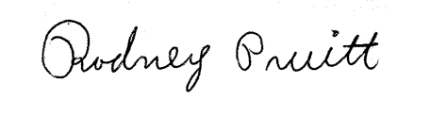
Rodney Pruitt
Specialist Project Sourcing
Supplier Quality Engineering

