Honeywell Sensing & Productivity Solutions
315 East Stephenson Street
Freeport Illinois 61032
Tel: (815) 235-6591

Dear Customer
Honeywell Sensing & Productivity Solutions takes its compliance with European Union Directive 2011/65/EU Restriction of Hazardous Substances (ROHS2) very seriously.
Directive (EU) 2015/863 amending ANNEX II on 31 March 2015 for additions to the restricted substance list

As part of our ongoing compliance commitment, we have completed a process to identify which, if any, substances are contained within the product we supply to you.

This communication refers to the latest release of RoHS noted below.

Manufacturer Part Numbers: | NGC Platform Products
Date of Directive Release | January 2nd 2013
Date of Review: | 8/20/2015
As part of this RoHS identification process we have:
- reviewed internal/publicly available engineering data in relation to the presence of RoHS in our products or any of their component parts;
- reviewed available safety data sheets for all our input materials;
- Communicated with our suppliers to exclude/confirm the presence of listed RoHS in any component parts of our products.
As a result of this process, we confirm that, to the best of our knowledge, the product we currently supply to you meets the RoHS directive.
Sincerely
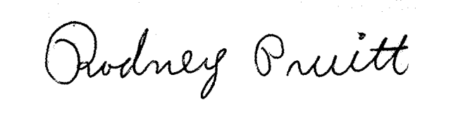

Rodney Pruitt
Specialist Project Sourcing
Supplier Quality Engineering

